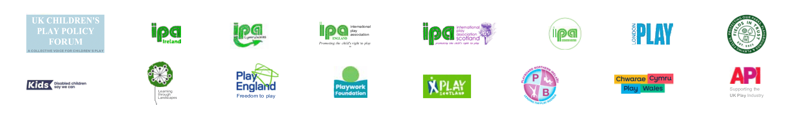
YOUR NAME

YOUR EMAIL

11th June 2025

Dear Headteacher / Principal,

RE: International Day of Play 2026 – Play 31 Challenge

In 2024, the United Nations declared 11th June each year as the International Day of Play, recognising that play is essential to children’s happiness, health, and learning. This year’s theme is Protect play, protect childhood.

The UK Children’s Play Policy Forum in collaboration with IPA Cymru Wales, IPA England, IPA Ireland | Éire, IPA Northern Ireland, and IPA Scotland are calling on all schools to take part in the Play 31 Challenge by giving children 31 more minutes of play during the school day.

The challenge is inspired by Article 31 of the UN Convention on the Rights of the Child (UNCRC), which states that every child has the right to play, rest, leisure, and participation in cultural and artistic life.

The ask is purposefully simple:

- 31 minutes
- No cost
- No equipment or special activities necessary

Just time, space, and permission for children to play.

I am writing to ask whether our / your school might take part in the Play 31 Challenge on Tuesday 11th June 2026. Even a small extension to playtime would give children the chance to enjoy unstructured play - something that benefits their wellbeing, relationships, and learning.

Thank you for taking the time to consider this request.

Yours sincerely,

Further information

This template letter was drafted by The Playwork Foundation:

🌐 playwork.foundation

International Day of Play:
🌐 un.org/en/observances/international-day-of-play

UK Children’s Play Policy Forum:

🌐 childrensplaypolicyforum.wordpress.com

International Play Association (IPA):

🌐 ipaworld.org/

National Play Organisations:

Chwarae Cymru | Play Wales 🌐 play.wales

Play England 🌐 playengland.org.uk

PlayBoard Northern Ireland 🌐 playboard.org

Play Scotland 🌐 playscotland.org

